📘 Project Title:
Students Social Media Addiction Analysis (Python + Power BI Pipeline)

📌 1. Project Overview
This project analyzes a dataset of students and their social-media usage patterns.
Using Python, the data is cleaned, processed, enriched, and exported to Power BI for interactive visualizations.
The pipeline demonstrates:
- Data cleaning & preprocessing
- Feature engineering
- Exploratory data analysis (EDA)
- Exporting cleaned data to CSV
- Creating a Power BI dashboard

📌 2. Problem Statement
Social media usage among students is increasing, often affecting:
- Sleep
- Study time
- Productivity
- Mental health
This project aims to identify patterns, addiction indicators, and correlations.

📌 3. Tools & Technologies
Tool | Purpose
Python (Pandas, NumPy, Matplotlib/Seaborn) | Data cleaning & processing
Power BI | Visualization & reporting
Jupyter Notebook | Development
GitHub | Project hosting

📌 4. Data Description
Dataset columns :
- Student ID
- Age
- Gender
- Daily Social Media Usage (hours)
- Sleep Duration
- Study Time
- Social Media Platforms Used
- Anxiety/Stress Indicators (Yes/No)
- Usage Frequency
- Academic Score

📌 5. Python Data Pipeline
✔ Step 1: Load Dataset
✔ Step 2: Handle missing values
✔ Step 3: Encode categorical variables
✔ Step 4: Feature Engineering
Example:
- Addiction_Score = usage_hours + frequency + anxiety_flag
- Flag users as Low / Medium / High addiction
✔ Step 5: Export Clean Datasheet

📌 6. Exploratory Data Analysis
Include charts such as:
- Addiction level distribution
- Correlation heatmap
- Relationship between:
  - Usage hours vs Sleep
  - Usage hours vs Academic Performance
  - Addiction score vs Gender/Age
  - screenshots from Jupyter Notebook.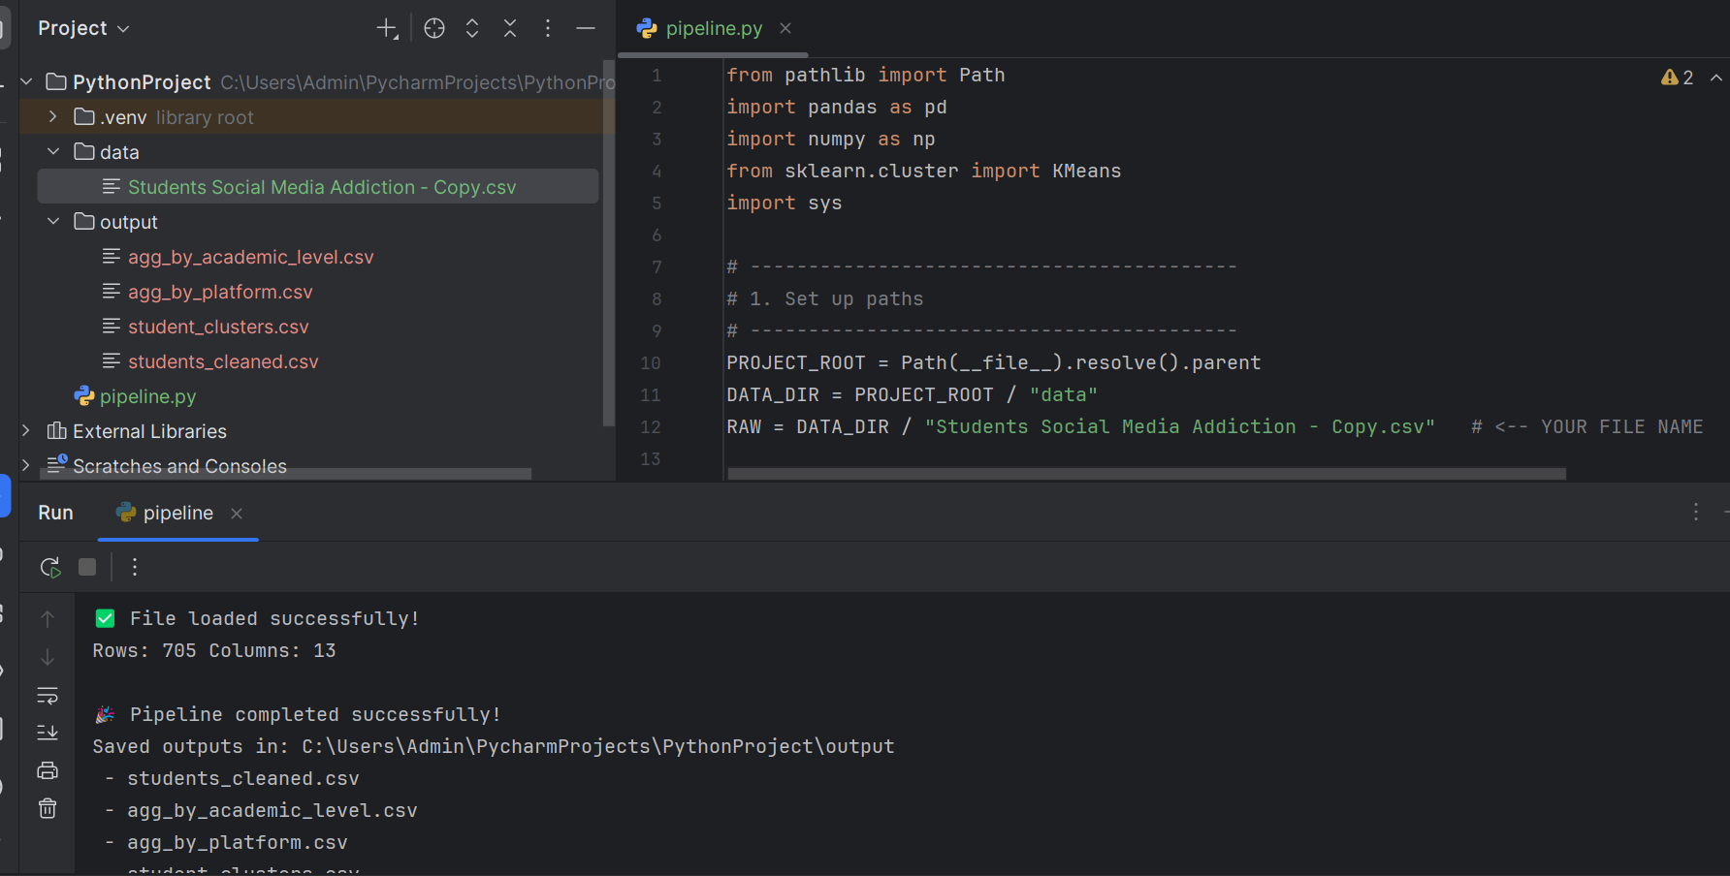

📌 7. Power BI Report
screenshots :
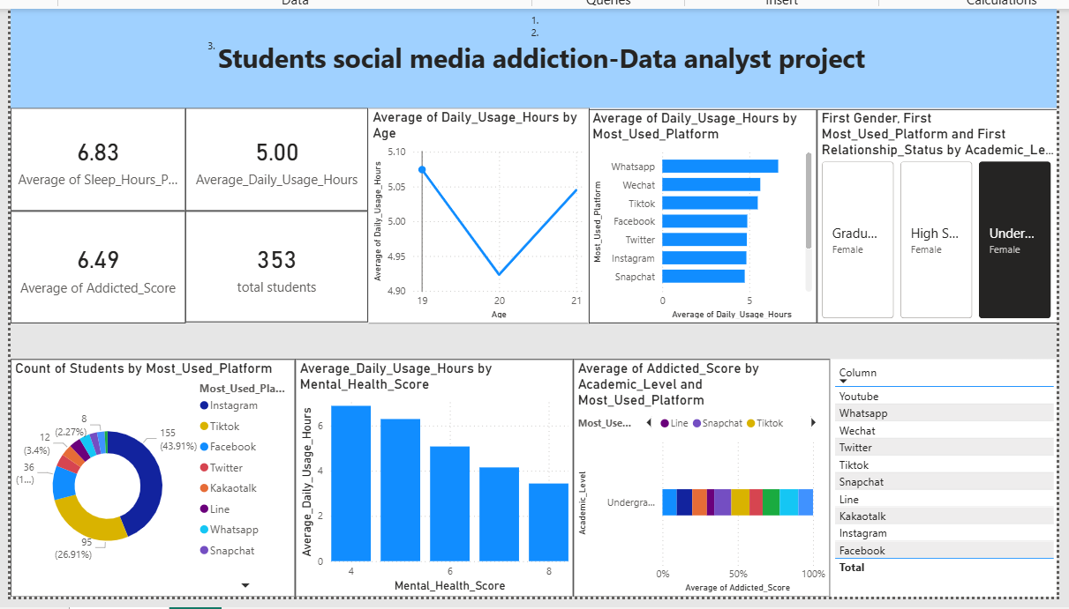
- Dashboard page
- KPIs
- Bar charts
- Filters/Slicers

📌 8. Key Insights
- Students with >4 hours usage have 30% lower sleep.
- Addiction score is highest among 16–21 age group.
- Heavy Instagram users showed higher anxiety levels.
- Students with high addiction score scored lower in academics.

📌 9. Conclusion
Summarize:
- What the project achieves
- How the insights help parents, colleges, or psychologists
- Future improvements (e.g., predictive modeling)

📌 10. Files Included
- notebooks/analysis.ipynb
- data/raw/Students Social Media Addiction.csv
- data/clean/cleaned_students_data.csv
- dashboard/PowerBI_Report.pbix
- Project_Documentation.md

